Part 1.0 - General

1.1 The irrigation central control system shall be the OASIS™ Central System as Manufactured by Rain Master Irrigation Systems, Inc.

1.2 The central system shall consist of the following general components:

- OASIS Central software.
- Evolution DX2 satellite controllers.
- Evolution flow and weather sensing devices.
- Evolution communication hardware.
- Personal computer utilizing a Windows® XP Professional operating system.

1.3 The OASIS Central Software shall be available in Standard, and OASIS-Lite versions. The OASIS-Lite version is identical to the Standard version but limited to fifteen Evolution DX2 satellite controllers and interface with a single weather station or OASIS Weather Center. All versions shall include Rolaid™ communication software for remote access to the central computer. (High-speed Internet connection is not required, but highly recommended.)

1.4 The OASIS Central Software shall be available with California Irrigation Management Information System (CIMIS) optional module. The CIMIS module is available to California users to facilitate ET acquisition from a user selected CIMIS weather center.

1.5 The OASIS Central Software shall have the following general features:

- Employ easy to use Visual Positioning Mapping (VPM).
- Capability to operate up to one thousand Evolution DX2 satellite controllers.
- Remotely perform all Evolution DX2 controller keystroke operations from the central computer.
- Scheduled events shall be successfully executed with or without the OASIS operating system open.
- Provide automatic and timely notification of system malfunctions.
- Display, print, and save over fifty report formats and export to Microsoft® Excel, Word or an Adobe PDF file.
- Provide mixed communication modes including hardwire, phone, radio, Ethernet and various forms of wireless communications.
- Support a central Weather Center and or multiple DX2 weather stations and their respective microclimates for rain, wind, and ET.
- Offer two methods of ET based water management, Basic or Advanced ET.
- Activate pump by program.
- Provide flow management for optimizing flow distribution and runtimes.
- Allow for global programming and scheduling changes.
- Display drawings and maps utilizing an optional AutoCAD-LT™ feature or DWG file reader.
- Ability to save and restore programs from a file.

  - The Visual Positioning Mapping (VPM) feature shall come with a standard street map view. Their shall be an option of enabling or disabling an Aerial Photograph view, specific to the area being controlled by OASIS. (See Figure 1.1 & Figure 1.2)

Part 2.0 - Programming Features

2.1 The OASIS Central System shall allow for the programming of each Evolution DX2 satellite controller. Each controller shall have twelve programs. Programs may be either irrigation or non-irrigation. Non-irrigation programs shall be for lighting, security, etc. Non-irrigation programs are independent of rain and freeze shutdown modes.

2.2 Each program shall have the following setup options:

- Specified start times (1-8) or a continuous cycle.
- Hour/minute or minute/second runtime format.
- Irrigation program, yes or no.
- Omit by date effect, on or off.
- Overlap protection, on or off.
- Over water limit, give warning or stop water.
- Inter-station time delay (0-255 sec).
- Either of two normally closed master valves, or one normally open master valve.
- Master valve time delay (0-600 sec).
- Pump operation, on or off.

2.3 Each program shall have three options for setting water days. Programmed days can use a 14-day calendar, a 31-day calendar or a Skip by Day schedule. All options shall allow for up to eight start times per program.

2.4 The central system shall allow for the programming of up to forty-eight stations per Evolution DX2 satellite controller. Stations may be assigned to more than one program. Station runtimes may range from 1 second to 24 hours. A ‘Quick Station’ function shall allow for the programming of a block of stations all with the same runtime.
2.5 Each program shall have a percentage adjustment feature (water budget). This feature shall allow all station runtimes within a program to be adjusted from 0 and 999% of their programmed runtimes that are defaulted at 100%.

2.6 The central system shall provide an automated ET (EvapoTranspiration) driven water management capability utilizing user-defined base watering schedules. ET data for this function may be obtained automatically from the OASIS Weather Center, Weather Station or entered manually by the user. An option is available to automatically obtain the ET data from a CIMIS Weather Center. A global ET percentage adjustment feature (0 - 999%) allows the user to make corrections for site differences.

2.7 The central system shall allow the user to enter base schedules and establish a reference ET from which all calculations is derived. On a daily basis, the software will automatically adjust run times for all stations dependent upon daily ET.

2.8 The central system includes a ‘Visual Positioning’ function that shall allow the user to review all programmed data within an Evolution DX2 satellite controller on a single screen using “point & click” Windows technology. Following are the View All options:

- Alarm – Shows all current alarms in the system.
- Programming – Shows the “Programming” screen of the controller.
- Blue Panel – Allows real time programming of any DX2 satellite with the “Blue Screen” display panel.
- AutoCAD – Shows layout of the area in “AutoCAD” if the appropriate software is installed on the computer system.
- Edit – Shows the “Add-Delete-Modify Controller” screen.
- Notes – Free form text file per controller.

2.9 The central system shall provide the capability to upload and download programs between the central computer and the Evolution DX2 satellite controllers. Programs may be automatically downloaded at times set by the user. Programs may be downloaded by type: all valid programs, all modified programs, or all programs. Programs may be uploaded and downloaded manually at anytime. The central system shall support programming changes in the field or at central. If a field change is made, the central user shall be notified via an alarm notification. The central user has the ability to view, modify, and/or reject, any field change(s) before acceptance into the central system database.

2.10 The central system includes a ‘Global Search’ function for Conventional, Basic ET and Advanced ET programs. The global search feature will display a list of stations based on user defined parameters. Once this list is created, stations may be programmed singularly, in selected combinations, or as a block (multiple stations, Evolution DX2 controllers or programs). Following are the global search options:

- Irrigation Modes – Basic ET, No ET or Advanced ET (Global Stations only).
- Start Times or Continuous Cycle
- Water days – (14 day, 31 day and Skip by Days schedule).
- Search by; Non-Irrigation program, MM:SS time scale and Overlap protection.

Part 3.0 - Maintenance Operations

  - The OASIS Central System shall allow each Evolution DX2 controller to be operated directly from the central computer. This is accomplished by utilizing an on-screen graphics replica of the Evolution DX2 controller control panel. All Evolution DX2 controller test functions are available to the user at the central computer.

  - The central system shall provide an automated mechanism for testing, measuring and recording nominal flow on a per station basis, global upper/lower adjust, individual limit adjust and download.

  - The central system shall provide an automated mechanism for testing, measuring, and recording nominal electrical solenoid current on a per station basis, global upper/lower adjust, individual limit adjust and download.

  - The central system shall be capable of monitoring flow from multiple flow sensors displaying real time G.P.M. and total gallons used.

  - The central system shall be capable of automatically reporting/recording more than 25 different central system and weather related alarms and conditions generating an audible, as well as visual indicator when any alarm(s) occur.

  - The central system shall be capable of automatically reporting/recording more than 30 different field Evolution DX2 controller alarm conditions generating an audible as well as visual indicator when any alarm(s) occur.

  - The central system shall provide the means for the user to send the time, date, controller name and omit by date irrigation cycle to an individual or all Evolution DX2 controllers.
  - The central system shall provide the means for the user to manually upload Evolution DX2 controller statistics from an individual Evolution DX2 controller or all Evolution DX2 controllers.

  - The central system shall provide the means for the user to manually download programs to an individual Evolution DX2 controller or all Evolution DX2 controllers. Programs may be downloaded by type: all valid programs, all modified programs, or all programs.

  - The central system shall provide a mechanism for the user to manually upload programs from an individual Evolution DX2 controller or all Evolution DX2 controllers or a group.

Part 4.0 - Accountability and Reports

4.1 The OASIS Central System shall allow for the on-line storage, review, and report generation of all historical system generated data for a period of 10 years (minimum). Reports may be generated for the following items: Evolution DX2 controller programs, Evolution DX2 controller alarms, central alarms, weather alarms, repeater alarms, radio alarms, Evolution DX2 controller events, EvapoTranspiration, flow meter, water usage, rainfall, and system transactions.

4.2 The central system shall provide an Evolution DX2 Controller Program Report. This report will display, print, and save Evolution DX2 controller program data which show all start times, station run times, total program runtime, water days, and program setup information on a per program basis. Report generation shall be for any individual, group, or all Evolution DX2 controllers with user defined options of valid programs only, modified programs, or all programs.

4.3 The central system shall provide an Evolution DX2 Controller Alarm Report. This report will display, print, and save Evolution DX2 Controller alarm and warning events that show various field related anomalies (over 30). Such events include: station upper and lower flow violations, main line break, unscheduled flow, solenoid electrical current upper and lower limit violations, station short circuits, power failures, monthly water over budget, wind/rain limit violations, configuration related programming errors, and communication failures. Alarms shall be date time stamped. Report generation shall be for any individual, group, or all Evolution DX2 controllers with user defined options:

- Start/stop date period, report by day, report by week (selectable week ending day), report by month (selectable month ending day), or report by period.
- Sort by time or by Evolution DX2 controller.
- Report/search by keyword.
- Report/search by specific alarm(s)/conditions.
- Shows report warnings.

4.4 The central system shall provide a Central and Weather Alarms Reports. This report will display, print, and save central alarm and warning events which show various system anomalies (over 25) including but not limited to: weather center (18) alarms, Evolution DX2 controller program download failures, water window violations, operator programming errors, phone connection failures, stations with too little irrigation (11). Alarms shall be date time stamped. Report generation shall be for any individual, group, or all Evolution DX2 controllers with user defined options:

- Start/stop date period, report by day, report by week (selectable week ending day), report by month (selectable month ending day), or report by period.
- Sort by time or by Evolution DX2 controller.
- Report/search by keyword.
- Report/search by specific alarm(s)/conditions.
- Shows report warnings.

4.5 The central system shall provide an Evolution DX2 Controller Event Report. This report will display, print, and save Evolution DX2 controller events that show individual station start/end times, runtimes and measured flow. Also included are master valve and pump start/end times, daily accumulation for flow meters, ET, and rainfall if applicable. Report availability for any individual, group, or all Evolution DX2 controllers with user defined options:

- Start/stop date period.
- Units can be displayed in gallons, centicubic feet (CCF), or acre feet.
- Sort by time or by Evolution DX2 controller.
- Shows measured flow.
- Shows report warnings.

4.6 The central system shall provide an EvapoTranspiration Report. This report will display, print, and save ET data for any microclimate with user defined options:

- Start/stop date period, report by day, report by week (selectable week ending day), report by month (selectable month ending day), or report by period.
- Resolution to Evolution DX2 controller (ET displayed per user selected Evolution DX2 controller) or system (ET displayed as a total of all user selected Evolution DX2 controllers).
- Shows averages.
- Shows report warnings.

4.7 The central system shall provide a Flow Meter Report. This report will display, print, and save flow meter data by flow meter F1 and F2 for any individual, group, or all Evolution DX2 controllers with user defined options:

- Start/stop date period, report by day, report by week (selectable week ending day), report by month (selectable month ending day), or report by period.
- Resolution to Evolution DX2 controller (flow displayed per user selected Evolution DX2 controller) or system (flow displayed as a total of all user selected Evolution DX2 controllers).
- Units can be displayed in gallons, centicubic feet (CCF), or acre feet.
- Sort by date or Evolution DX2 controller.
- Shows flow meter averages.
- Shows report warnings.

4.8 The central system shall provide a Water Usage Report. This report will display, print, and save water usage data which shows both runtime and flow data for any individual, group, or all Evolution DX2 controllers with user defined options:

- Start/stop date period, report by day, report by week (selectable week ending day), report by month (selectable month ending day), or period.
- Resolution to Evolution DX2 controller (water usage displayed per user selected Evolution DX2 controller) or system (water usage displayed as a total of all user selected Evolution DX2 controllers).
- Units can be displayed in gallons, centicubic feet (CCF), or acre feet.
- Sort by time or Evolution DX2 controller.
- Shows water usage averages.
- Shows measured versus calculated flow data.
- Shows report warnings.

4.9 The central system shall provide a Rainfall Report. This report will display, print, and save rainfall data for any microclimate with user defined options:

- Start/stop date period, report by day, report by week (selectable week ending day), report by month (selectable month ending day), or period.
- Resolution to Evolution DX2 controller (rainfall displayed per user selected Evolution DX2 controller) or system (rainfall displayed as a total of all user selected Evolution DX2 controllers).
- Shows rainfall report averages.
- Shows report warnings.

4.10 The central system shall provide a System Transaction Report. This report will display, print, and save system usage events and operator initiated transactions, by date and time.


4.12 The central system shall provide an on Map screen and in Menu “Red Triangle” visual indicator when any alarm(s) occur that may require operator intervention for any problem or system circumstance. Users may “drill down” on any visual indicator to obtain specific information about the alarm. These indicators are dynamic and shall be physically placed next to the affected area(s) of operation. Following are the central system menus and sub-menus that will display a Red Triangle:

- Alarms – Central, Controller, Weather, Repeater and Base Radio Alarms.
- Weather Center – Weather Calendar, Rain (Shutdown), Wind (Shutdown).
- Scheduled Events – ET Acquisition, Statistics Upload, Recalculation, Program Download, Alarm Polling, Weather Polling, and Program Validation.

Part 5.0 - Communications

5.1 The OASIS Central System shall utilize two-way communication throughout the entire system. Data transmissions shall utilize appropriate protocols to insure reliable error-free communications.

5.2 The central system shall support serial port expansion to accommodate singular, combined, and repeater communication modes. Available communication options are hardwire, telephone modem, UHF Narrow Band FM radio, trunk radio, store and forward UHF FM radio, wireless cellular and interface to an Ethernet Area Network.

5.3 The central system shall provide built-in software for verifying communication path performance and troubleshooting.

5.4 The central system shall successfully execute all scheduled events in the background with or without the OASIS operating system being executed.

5.5 The system shall be capable of uninterrupted Evolution DX2 controller operation in the event that the central computer is not operational or communication failure with one or more Evolution DX2 controllers has occurred.

Part 6.0 - Weather Center

6.1 The central system shall utilize the OASIS Weather Center and or DX2 Weather Stations for rain, wind, and EvapoTranspiration data. EvapoTranspiration (ET) data shall be generated from a Weather Computer and rain data shall be stored indefinitely in the central system database.

  - The central system shall support up to 20 independent microclimates (for rain, wind, and ET) to accommodate Evolution DX2 controllers in different geographic areas to be managed from the central computer.

  - The central system shall allow for automatic freeze shutdown and restart of irrigation program schedules on a per microclimate basis in response to a freeze sensing device. The freeze shutdown option shall be a subset of the rain shutdown option. Rain shutdown functions shall have priority over freeze shutdown functions. Rain shutdown and freeze shutdown functions share microclimates; this means the central operator must first create a rain microclimate before a freeze microclimate can be created.

  - The central system shall allow for automatic rain shutdown of irrigation program schedules on a per microclimate basis when a specified rate (inches/hour) and/or a daily amount (inches/day) have been measured. The central user shall have two methods for rain restart, manual or semi automatic. In manual mode the Evolution DX2 controller(s) will remain in rain shutdown until the central operator removes the rain shutdown. In semi automatic mode the central system will automatically remove the Evolution DX2 controller(s) from rain shutdown after a user specified number of days.

  - The central system shall allow for automatic wind shutdown of program schedules on a per microclimate basis when a specified rate (mph) has occurred for a specified time (minutes). Automatic program resumption shall occur on a per microclimate basis when a specified rate (mph) has occurred for a specified time (minutes).

  - The central system shall provide a Weather Calendar display. The Weather Calendar shall be a graphical display of the months of ET and rain information gathered from an Evolution Weather Center, a CIMIS Weather Center, or User input. Once the information has been gathered for a particular day, a color code is applied to the display to visually show the user how the information was obtained. Following are the Weather Calendar color code options:

Red – Automatic acquisition failed.
Blue – Valid rain reading.
Green – Valid ET reading.
Brown – User override entry.
Black – Default entry / Historic.

6.7 The central system shall provide a Microclimate Review mechanism. The user shall be able to review microclimate assignments for ET, rain and wind, per Evolution DX2 controller.

  - OASIS Weather Center with Visual Weather® shall provide real-time, onscreen, graphically depicted, weather information.

Part 7.0 – Single Computer for Multiple Users Configuration

7.1 A single computer/server can be setup with multiple users. Users shall access the same computer/server and can be assigned an individual user-ID and password. The system shall allow for up to ten (10) users plus an administrator per system (maximum 11).

7.2 The presentation of the data shall be particular to the user that is logged on at the time, only the controllers that are assigned to that user shall be displayed. Multiple users may not be logged in at the same time.

7.3 Shared devices shall be displayed on the map regardless of who is logged on. These devices include:
    - Oasis Central location
    - Base Radio locations
    - Repeater locations

7.4 The administrator shall have the following responsibilities:

    - The administrator shall have the ability to add/delete/modify the controllers for the system.
    - The administrator shall have the ability to add/delete/modify the weather stations for the system.
    - The administrator shall have the ability to add/delete/modify the communications devices for the system. This includes Base Radio, Repeaters, Modem to Modem, Phone Modem, CDMA Wireless, Ethernet and Hardwire communications.
    - The administrator shall have the ability to add/delete/modify the positions of all components onto the map display.
    - The administrator shall have the ability to add/delete/modify any Scheduled Events that are to take place.
    - The administrator shall have the ability to add/delete/modify all User information and assignment of controllers to the users.
    - The administrator shall have the ability to produce reports for ALL controllers in the system.

7.5 The users shall have the following responsibilities:

    - The user shall have the ability to monitor the controllers assigned to them.
    - The user shall have the ability to monitor and maintain all programming information for each controller assigned to them.
    - The user shall have the ability to produce reports and charts that are particular to only the controllers assigned to them.
    - The user shall not have access to add/delete/modify any of the shared resources for purposes other than viewing only.
    - The user shall have access to all Manual Operations for each controller assigned to them within in the system

Figure 1.1 displays the standard map view included with OASIS

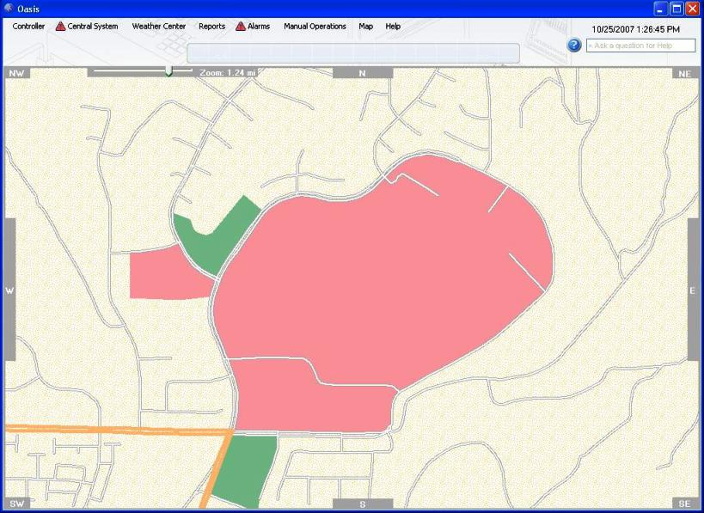
Figure 1.1

Figure 1.2 depicts the same display area with the optional Aerial Photography layer

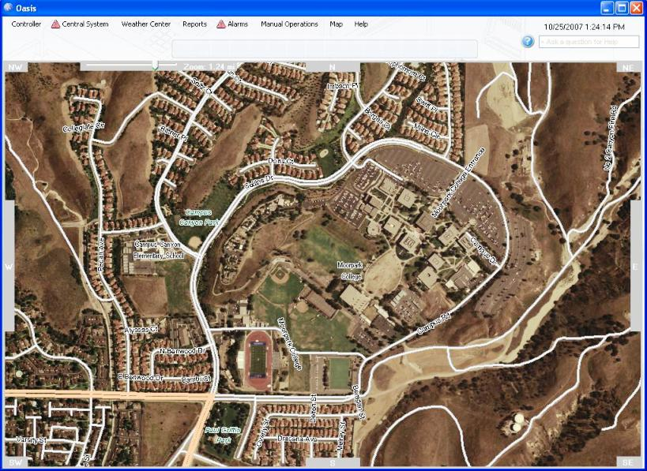
Figure 1.2

