Rain Master’s Weather Center II is an optional Weather Sensing interface for the EV2000 Central Control System. The device connectivity is to a Rain Master Evolution DX2 irrigation controller. Evapotranspiration (ET) data, Rain data and Wind data is then transferred to the EV2000 Central Control System, for processing and dissemination.
Rain Master’s Weather Center II can also be used as an optional weather sensor for the RME Eagle Irrigation Controller.
INTRODUCTION
The water requirements for the landscape can be determined in several ways; visual inspection, soil moisture sensors, evaporative pan measurements or by using Evapotranspiration (ET). Weather data is used to calculate ET, which is expressed in inches of water lost from the landscape over a given period of time. Temperature, wind, solar-radiation and humidity values are collected and logged every 10 seconds by the weather computer.
Rain Master Irrigation Systems EV2000 Central Control System was designed to collect the weather data, use the ET value provided by the Weather Center II, and send an adjusted irrigation schedule to the Evolution DX2 irrigation controllers.
Using the EV2000 Central Control System provides a accurate and reliable method of obtaining the ET data, prevent watering when it is raining, cancel watering in freezing conditions and interrupt irrigation in high wind conditions.
The Weather Center II must be located in a location that accurately represents the geographic area of the landscape. Weather patterns, elevation, geography, exposure, obstructions and surrounding landscape all play a role in determining the limits of effective coverage of a weather center.

WEATHER CENTER II
The Rain Master Weather Station is comprised of four major measuring devices, these include:
- Solar Radiation Sensor
- Temperature/Relative Humidity Sensor
- The Tipping Bucket Rain Gauge
- The Wind Speed Sensor (Anemometer)
The measured values are transmitted to the Rain Master Evolution DX2 Irrigation Controller. The electrical signals are counted and stored in memory of the controller; the EV2000 Central Control System then requests the data. The EV2000 Central Control System uses the weather data to recalculate the irrigation schedules for all controllers within a particular microclimate. The revised schedules are then transferred to the Evolution DX2 field irrigation controllers.
Each of the measuring devices is permanently mounted onto a vandal-resistant tower with all connections made within the tower’s terminal block. The Evolution DX2 Controller, to which the Weather Center II is attached, supplies power to the system.

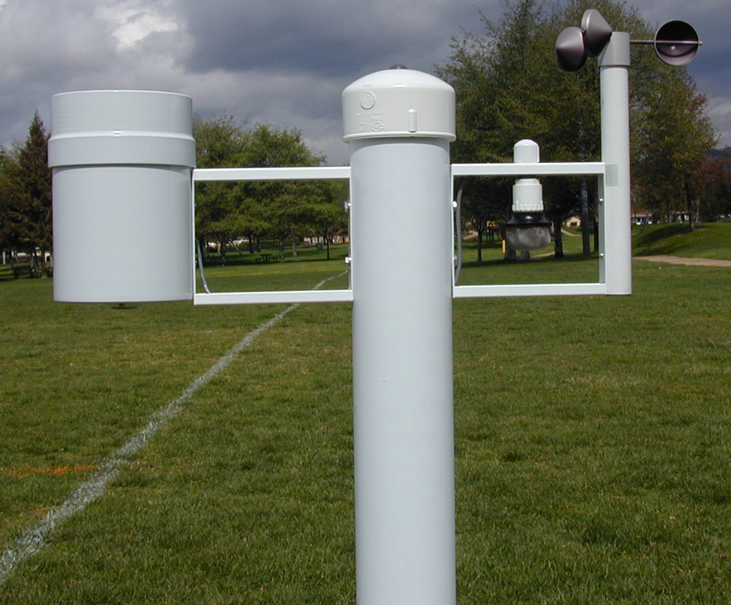

Below are the specifications for the Rain Master’s Weather Center Device.

Sensor Output |  | Evapotranspiration (ET), Rain and Wind Speed
Electrical Interface |  | Pulsed Signal Output based on .01 inches of ET, Wind Speed in Meters per second, and Rain Fall in .01 inches
Sensor Interface |  | 12 conductor cable set
Serial Interface |  | Female DB9 serial port with DCE configuration
Scan Rates |  | Once per second
ET Data Output Rate |  | Calculated every ten seconds transmitted every 10 minutes.
Wind Speed |  | Scanned and Output every second
Rain Fall |  | Output every .01 inches of rain fall.
Solar Radiation Sensor |  | Input Range 0 < V < 2.5 VDC, 0.6 mV resolution
Temperature Sensor |  | Input Range 0 < V < 2.5 VDC, 0.6 mV resolution
Relative Humidity Sensor |  | Range +/- 2.5 or +/- 5.0 VDC accuracy +/- 25 mV
Rain Fall Sensor |  | 1.0% at one inch per hour or less
System Firmware |  | Flash ROM standard; downloadable from the serial port
LED’s |  | Wireless Comm.(green) - Not Used  Scanning (red)
Physical Dimensions  (H x W x D) |  | Weather Pole: 4.0 inches x 29 inches x 12.0 feet (10.2 cm x 73.7 cm x (365.8 cm)  Weather Computer: 5 ½ inches x 2 inches x 3 inches (14 cm x 5.1 cm x 7.6 cm)
Shipping Dimensions  (H x W x D) |  | Weather Pole:12 feet 6 inches x 9 inches  (381 cm x 22.9 cm x 22.9 cm)  Weather Components: 16 inches x 16 inches x 37 inches (40.6 cm x 40.6 cm x 94 cm)  Total Weight: 81 lbs (36.8kg)
Power Requirements |  | External plug-in transformer included  Required input power of 110 VAC, 12 VDC @ 0.2mA max.
Environmental |  | Operating Temperature  -40 to 50°C (-40 to 122°F)  Storage Temperature  -40 to 66°C (-40 to 151°F)
Agency Approvals | CE Compliance

